# 

Insurance Agent Portal

IAP-001

Detail Level Design (SSAD)

**Record of Release**

|  |  |  |  |  |  |
| --- | --- | --- | --- | --- | --- |
| **Version No.** | **Modified By** | **Reviewed By** | **Authorized By** | **Release Date** | **Modifications Done** |
| 1.0 | Shreyash.A,Varun K., Kartik P. | Simran K. | Jitesh M. | 30-08-2020 |  |
|  |  |  |  |  |  |
|  |  |  |  |  |  |
|  |  |  |  |  |  |
|  |  |  |  |  |  |

**Table of Contents**

***1.0 Database Design / Class Design 3***

***2.0 Processes / State Transition Diagrams 3***

***3.0 User Interface Design 3***

***4.0 Module Specifications 3***

*4.1 Module Overview 3*

*4.2 Function Specifications 3*

*4.3 External Components Used 3*

# Database Design / Class Design

**Class: Horizontal Slider**

Attributes:

* Images presented in the slider

**Class: Our Services**

Attributes:

* Image for the class
* Name of service

**Class: Our Vision**

Attributes:

* Text information regarding vision

**Class: EMI Calculator**

Attributes:

* Amount
* Time Duration
* Interest
* Calculated EMI

Methods:

* Formula given by the customer

**Class: News Section**

Attributes:

* Image for the news
* Description of the news

# Processes / State Transition Diagrams

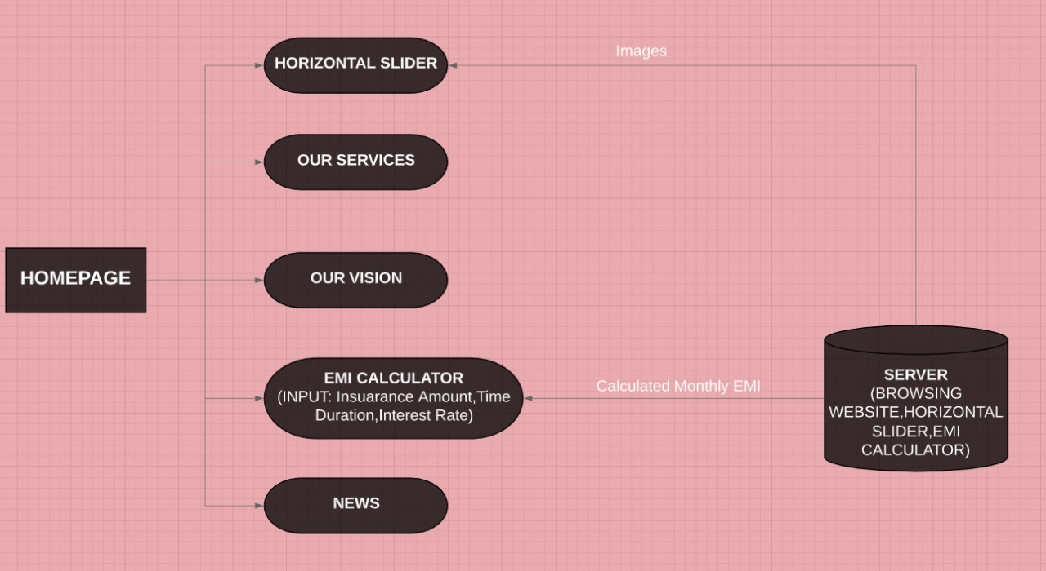

# User Interface Design

|  |  |
| --- | --- |
| **HOMEPAGE** | |
|  | Horizontal Slider:   * 3 Sliding images given directly from the server   Our Services:   * Heading :  1. text-align: center 2. font-size:30px 3. color: #cf1717  * An Image showing the services provided * Text area of the services provided  1. margin-bottom: .5rem 2. font-weight: 500 3. line-height: 1.2 |
|  | Our Vision   * Heading:  1. text-align: center 2. font-size:30px 3. color: #cf1717  * Text area showing about the vision of the agents company  1. margin-bottom: .5rem 2. font-weight: 500 3. line-height: 1.2   EMI Calculator |

# Module Specifications

## Module Overview

|  |  |
| --- | --- |
| **HOME PAGE** | |
| Functions provided | * Horizontal Slider * Our Services * Our Vision * EMI Calculator * News Section |
| Requirement IDs | CB, LC, HS, NS (Refer RTT document for IDs) |
| The logic of the module | The homepage is the first page which will be shown to the user whenever he/she visits the site.  Here, they can see the vision, services, news, images and can calculate the EMI. |
| Interfaces to other modules | NIL |
| Third-Party Components /Externally sourced modules to be used | * Angular * Visual Studio Code |
| Hierarchy Diagram |  |

## Function Specifications

|  |  |
| --- | --- |
| **HOME PAGE** | |
| Functions provided | * Horizontal Slider * Our Services * Our Vision * EMI Calculator * News Section |
| Requirement IDs | CB,LC,HS,NS (Refer RTT document for IDs) |
| The logic of each function | Horizontal Slider: in this the user will be able to see 3 slidable images when he visits the homepage.  Our Services: In thus the user will be able to the see the services provided from the agent to the client.  Our Vision: In this the user will be see the vision of the agent company.  EMI Calculator: In this the user will be able to calculate the EMI he has to give to the bank or to the agent.  News Section: In this the user will be able to see the latest news in the field of bank and insurance policies |
| Interfaces to other modules | NIL |
| Inputs and Outputs | **Inputs:**  Emi Calculator  Amount, interest rate, time  **Output:**  Emi Calculator  Money to be given per month |
| Exceptions | Error in calculation in EMI since the client may add wrong information in the inputs and may not get the desired output. |

## External Components Used

No external components are used in this module.